**Computational Astrophysics HW2**

R08244002 蔡欣蓉

* **Riemann Problem**

1. **Strong shock problem: Compare Lax-Friedrichs, Lax-Wendroff, and MUSCL-Hancock schemes.**

The black line is the analytical solution.

We can see that Lax-Fredrichs cannot express the contact discontinuity, and shock wave, or any angular structure correctly. The way the scheme works is to dissipate some source so that it is stable, so all the sharp and uncontinuous part’s performance are really bad.

Lax-Wendroff has some unphysical oscillations near the discontinuity part, though it can catch most of the waves structures.

MUSCL-Hancock matches the analytical solution the best. It is like a dissipative mode of Lax-Wendroff. Since in data reconstruction, some higher terms are wipe out.  
Run *Lax-Fredrichs.py, Lax-Wendroff.py,* and *MUSCL-Hancock.py* to reproduce these images.

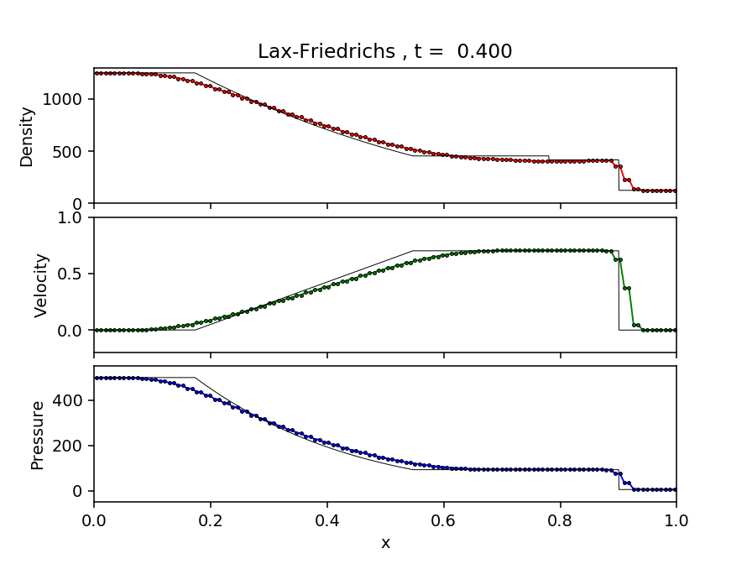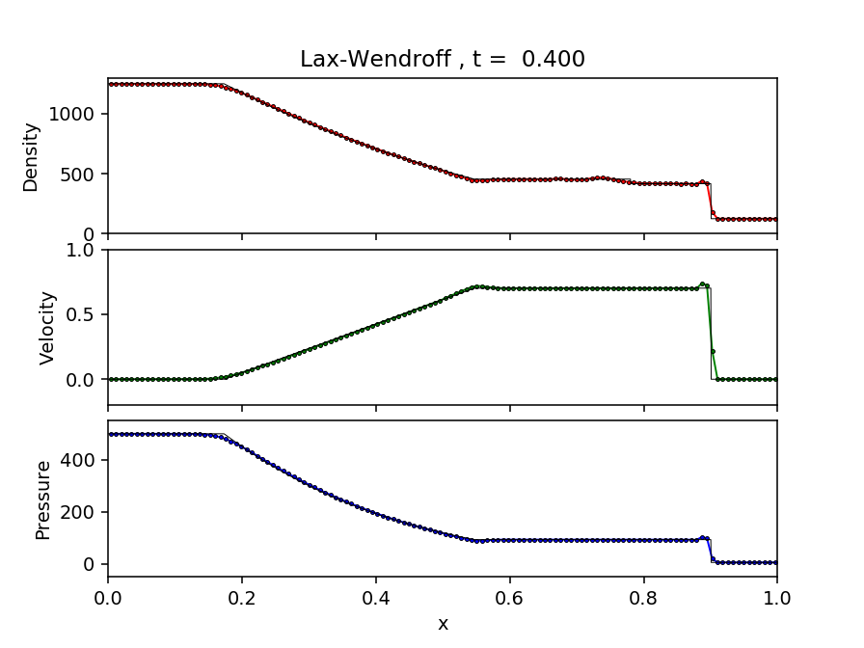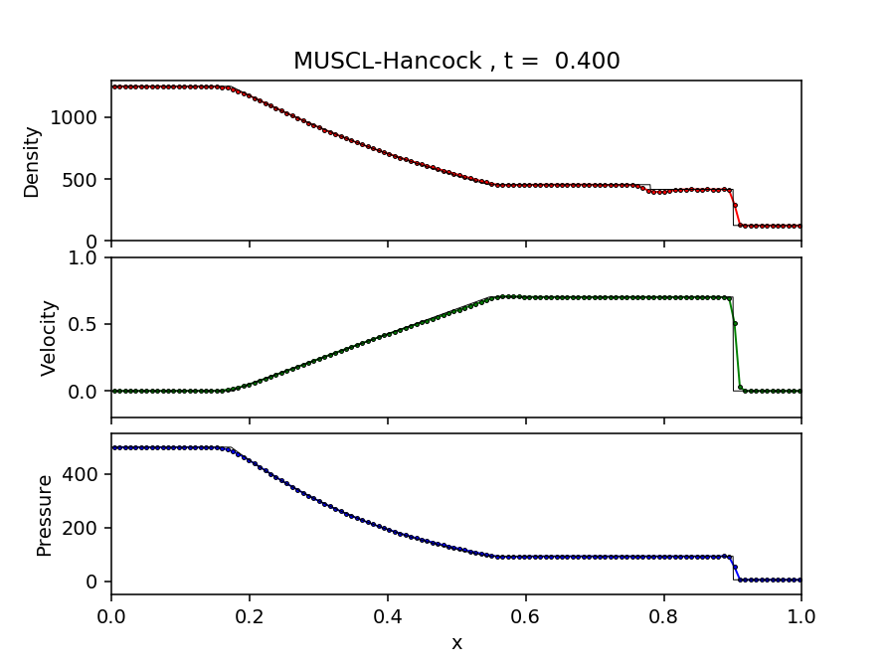

1. **For the MUSCL-Hancock scheme, find a Riemann problem that crashes the code and pin down the cause.**

Set the Riemann problem as:

and

It crashed at and gave the error message: “negative pressure !!”

Since we use energy E, density , and velocity to find the pressure, even though they suffer from the truncation errors. When the kinetic energy (velocity) is so large, it takes up most of the energy partition. And since energy and velocity evolve independently, the contraction between them sometimes lead to negative.

* **Run a test problem with AMR code**

1. **Run the code with Enzo AMR**

Run enzo with parameter list and settings same as the first problem. Plot the analytic solution and result from enzo together with Python, save in file *Plot.py*.

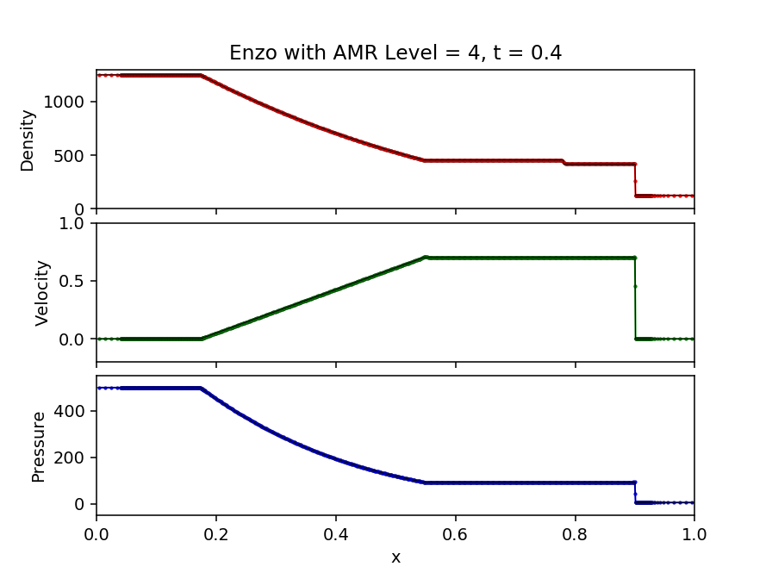The black solid line behind is the analytic solution.

1. **Sod shock tube**

A 1D Hydro simulation, that test how good a code captures and resolve shocks and contact discontinuity, and reproduce the rarefaction wave.

I use the initial condition same as the first problem. So we can compare all of them together, and I don’t have to search from the analytic solution!

1. **Grid refinement criteria**

It is refined by slope, the local gradient of the variables.

1. **Boundary conditions**

The boundary conditions are set to be transmissive for shock tubes.

1. 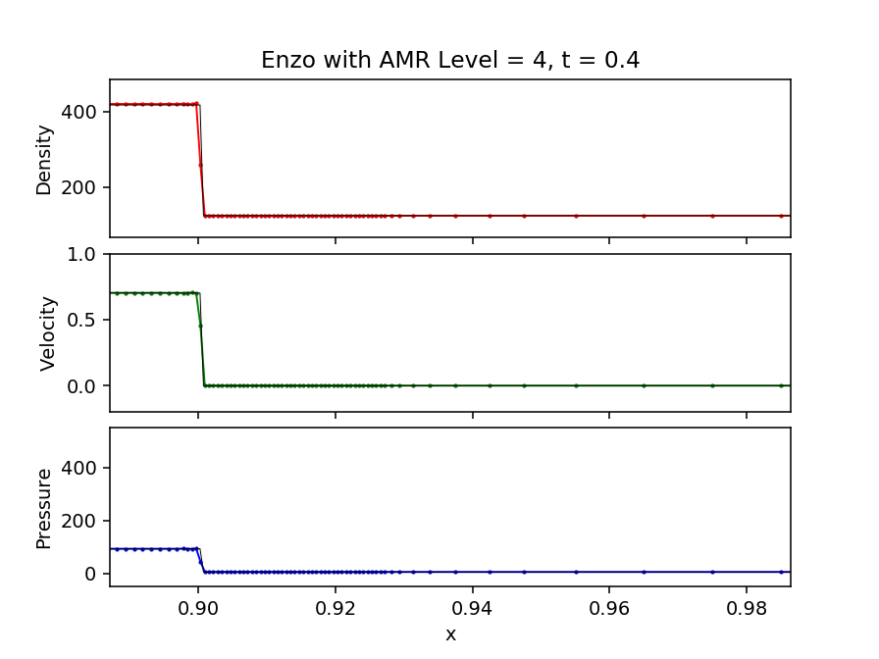**Compare to analytic solution and the other scheme in the first question**

It describes the discontinuity part better than all the other three scheme. In Enzo, the points near the discontinuity or angular parts won’t affect the others, however, the other three schemes will.

We can clearly see that in Enzo, their spatial resolutions are different at different grids, unlike the other three.

1. **Compare the results with different AMR levels.**

Due to the refinement criteria and the time interval, and the given problem, the maximum AMR level Enzo can draw is 4.

Compare the discontinuity part, we can see that it converges. As AMR level goes up, the Enzo result is closer to the analytic solution.

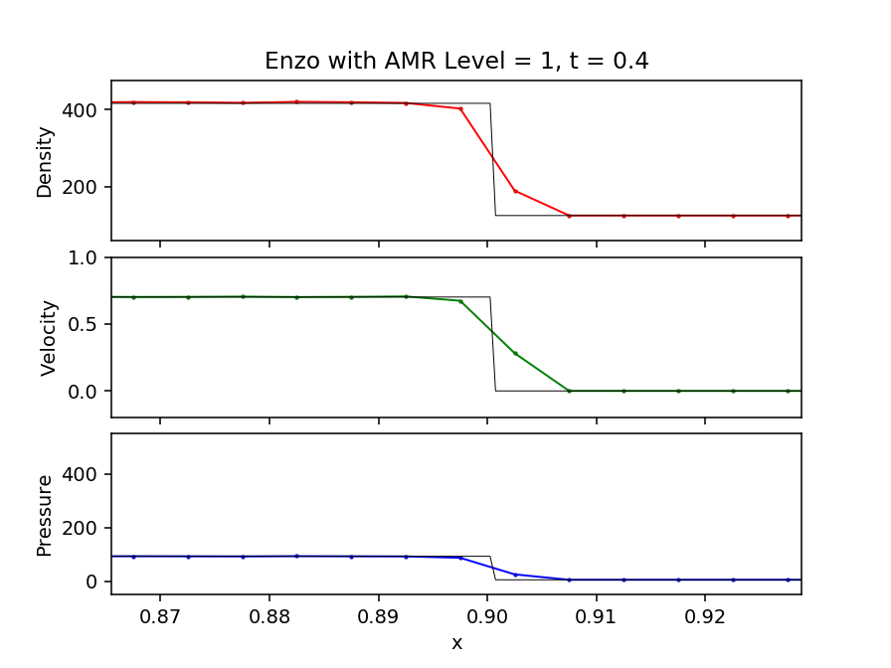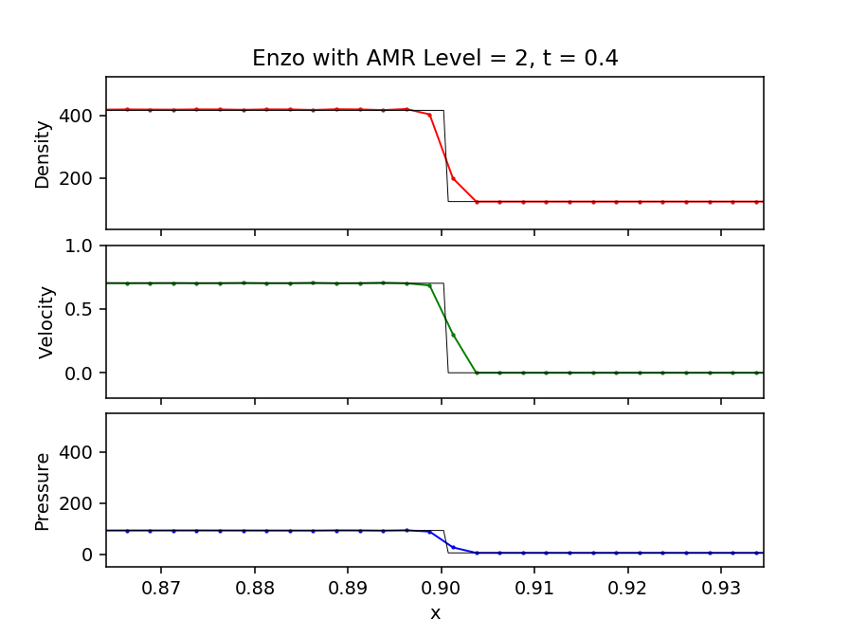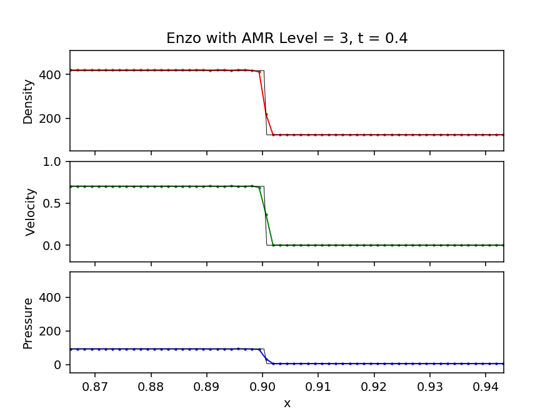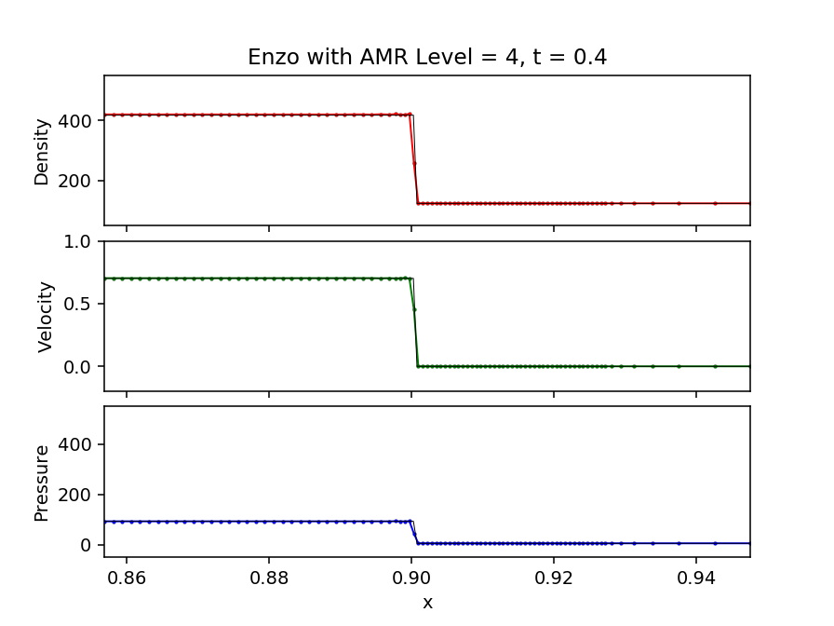

* **Show that**

Is to show all the direction of , summing up the terms containing is equal to zero, so that .

